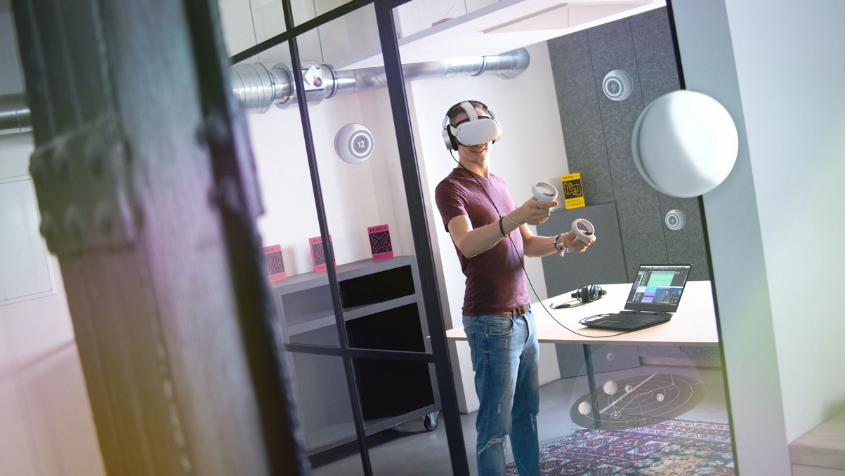

Boosting your spatial music mixing workflow
Dear Reality’s dearVR SPATIAL CONNECT introduces VR mixing to Cubase 12

Düsseldorf, Germany, October 24, 2023 – Spatial audio expert Dear Reality introduces its VR mixing controller, dearVR SPATIAL CONNECT, to Steinberg’s Cubase 12, extending its built-in Dolby Atmos capabilities. The VR application streamlines spatial audio productions, enabling extensive in-headset control of the most-used DAW functions and the dearVR PRO spatializer plugin. dearVR SPATIAL CONNECT facilitates intuitive positioning and automation of audio tracks via gesture control in a virtual 360° environment. In combination with Dear Reality’s dearVR MONITOR headphone monitoring plugin for multi-channel speaker setups, Cubase users can now benefit from a professional toolset that brings spatial productions to the next level.

Spatial audio redefines how artists, engineers, and listeners interact with sound. The new audio standard envelops the listener and provides a much more emotional auditory experience by having sounds arrive from every angle and distance. To unlock creative mixing possibilities and to empower producers to craft more lively and engaging music productions, Dear Reality introduces its VR application to Steinberg’s Cubase 12 audio workstation. “With the latest dearVR SPATIAL CONNECT update, we make our VR mixing solution available to a wide range of music producers mixing Dolby Atmos in Cubase 12,” says Dear Reality co-founder Christian Sander. “This combination enables them to experience a revolutionary way of working with spatial audio. By optionally adding our dearVR PRO spatializer and the dearVR MONITOR virtual headphone mix room, engineers benefit from a complete spatial audio ecosystem where they can spatialize, control, and monitor spatial audio sessions. “

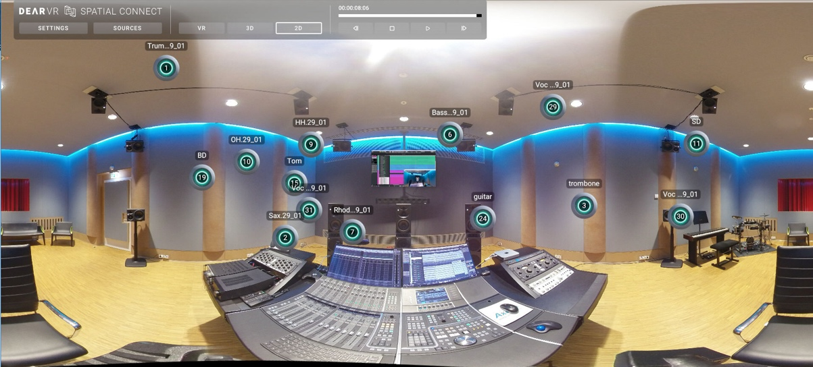
dearVR SPATIAL CONNECT provides a comprehensive overview of a spatial audio session by simulating the audio placements in a VR environment

By linking a VR headset like the Meta Quest or HTC Vive with their DAW, users can position and automate audio tracks in the virtual space by pointing at them with two handheld controllers. dearVR SPATIAL CONNECT enables direct VR access to the position, channel volume, solo & mute, and the automation status. This gesture-controlled process speeds up the mixing workflow and leads to more lively and authentic automations. “When positioning and automating sounds, we shouldn’t be limited by drawing automations in the DAW with the mouse or copy and paste automation lines,” concludes Felix Lau, Product Owner at Dear Reality. “When mixing spatial audio content, we should explore the space without any restrictions.”

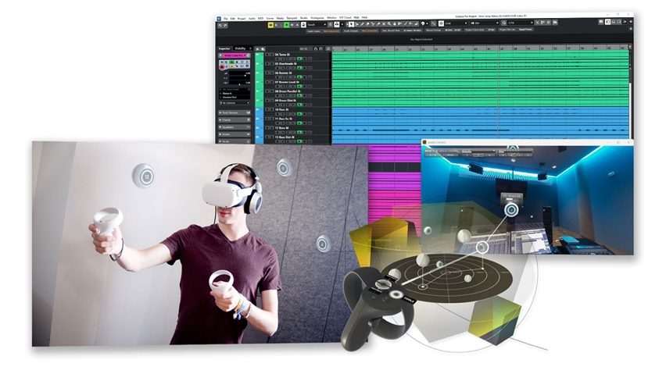 | dearVR SPATIAL CONNECT enables total control when mixing spatial audio productions

In addition, dearVR SPATIAL CONNECT provides overlay modules for extended navigation and control in the VR headset. The main control module enables direct control of Cubase 12’s transport functions like start, stop, and rewind. Furthermore, users can directly jump through the timeline and set markers and loop points. The meter bridge module brings the traditional mixing console we all know and love to the VR world. In this module, users control each audio channel’s volume, solo, and mute status. When the mixing session grows in complexity, the “minimap” module provides a comprehensive overview of all audio sources in the scene. It is an interactive, miniature view of the whole session and reflects the surrounding VR space, the audio sources, and their automation in real time.

dearVR SPATIAL CONNECT’s transport, meter bridge, and “minimap” overlay | 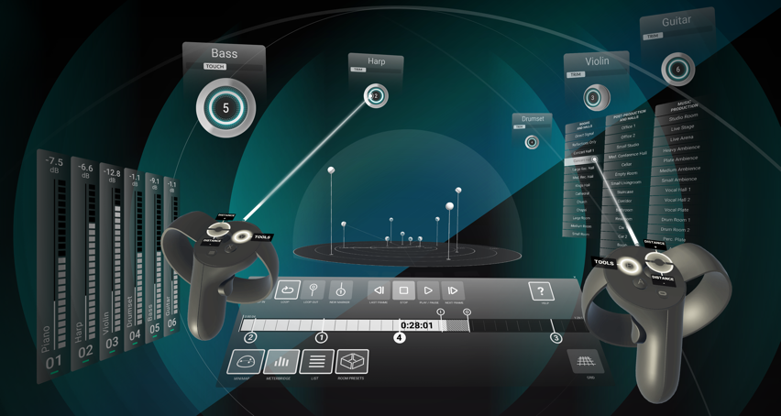

Based on the selected operating system, dearVR SPATIAL CONNECT can run on the same Windows machine as the DAW or in an easy-to-set-up two-machine setup. This allows the user to run the VR application on a Windows machine while running Cubase 12 on a Mac OS. dearVR SPATIAL CONNECT now supports Apple M1/M2 processors and connects with Nuendo 12, Cubase 12, and Reaper.

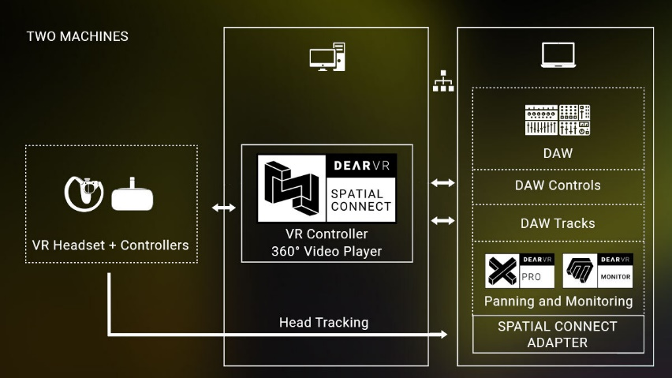 | dearVR SPATIAL CONNECT in a two-machine setup

(Ends)

The images accompanying this press release can be downloaded here (LINK)
More information: https://www.dear-reality.com/products/dearvr-spatial-connect

CUBASE and NUENDO are trademarks of Steinberg Media Technologies GmbH.
DOLBY ATMOS is a trademark of Dolby Laboratories, registered in the U.S. and other countries and regions.
META QUEST is a trademark of Meta Platforms, Inc., filed in January 4 (2022), the META QUEST covers Virtual, augmented and mixed reality headsets.
HTC VIVE is a trademark of HTC Corporation, filed in April 9 (2015). The HTC VIVE covers Interactive virtual reality system, namely, hardware for virtual, augmented and mixed reality.
WINDOWS is a trademark of Microsoft Corporation, registered in the U.S. and other countries and regions.
APPLE and MACOS are trademarks of Apple Inc, registered in the U.S. and other countries and regions.
REAPER is a trademark of Downhole Products Limited, registered in the U.S. and other countries and regions.

About Dear Reality
Dear Reality is a leading company in the field of immersive audio controllers and is best known for its binaural, Ambisonics, and multichannel spatializers with totally realistic room virtualization. Sound engineers, sound designers, broadcasters, and musicians use the company's products worldwide. Founded in 2014 by Achim Fell and Christian Sander, Dear Reality strives to deliver high-quality, cutting-edge 3D audio software for interactive and linear audio production. Since 2019, Dear Reality has been proud to be a part of the Sennheiser Group.

Global Press Contact

Kai Detlefsen
press@dear-reality.com

